**SOFTWARE PROJECT**

**SYBSC (COMPUTER SCIENCE)**

**TOPIC OF PROJECT-HOSPITAL MANAGEMENT SYSTEM**

**DIVISION -B**

**ASSIGNMENT 1.1:** Problem definition and scope

1.Problem definition: There are many problems in the existing system likewise-

a) The information is very difficult to retrieve. For example-to find out about the patient’s history, the user has to go through various registers.

b) Preparation of accurate and prompt reports: -This takes time and is a difficult task to collect information from old registers.

c) Manual calculations are error prone and takes a lot of time. This may result in incorrect information. For example- calculation of patient’s bill based on various treatments.

d) The information generated by various transactions takes time and effort to be stored at a right place. Various changes in information like patient details or immunization details of a child are difficult to make as paperwork is involved.

So, in order to overcome these drawbacks our team has proposed a new system that will provide security and proper data management and will be more efficient than the existing system.

Objective: Hospitals are the essential part of our lives, providing best medical facilities to people suffering from various ailments, which may be due to change in climatic conditions, increased work-load, emotional trauma, stress etc. It is necessary for the hospitals to keep track of its day-to-day activities and records of the patients, doctors, nurses, ward boys and other staff personals that keep the hospital running smoothly and successfully. But keeping track of all the activities and their records on paper is cumbersome and error prone. It is also a very inefficient and time-consuming process. Observing the continuous increase in population and number of people coming to the hospital; recording and maintaining all these records is highly unreliable, inefficient and error-prone. It is not economically and technically feasible to maintain these records on paper. Thus, keeping the working of the manual system as the basis of our project, we have developed an automated version of the manual system. The main aim of our project is to provide a paperless hospital up to 90%. It will also aim at providing a low-cost reliable automation of the existing systems and will also provide robust and reliable storage along with backup facilities.

2. Scope of the proposed system

Our proposed software product is Hospital Management System. The system will be used in any hospital, clinic, dispensary or pathology labs to get information from the patients and then storing the data for future storage. The current system in use is a paper-based system. It is too slow and cannot provide updated lists, pay and increase the number of patients that can be treated accurately. The main purpose of our project is to make hospital tasks easy and to develop software that replaces the manual hospital system into an automated healthcare management system.

Activities that the proposed software will do-

1.Manage doctor’s as well as patient’s accounts.

2.Creating prescriptions for patients.

3. Create Inpatient and Outpatient reports.

4. Create error free transaction reports of patients payments.

5.Create ,manage appointments with patients.

6. Providing treatment reports .

7.Maintaining patients diagnosis details and correct report generation.

**ASSIGNMENT 1.2:** Requirements specifications:

1.Hardware Requirements for this project:

**Processor**:intel core

**RAM**:4GB

**Hard disk**:1TB(Minimum 80GB)

2.Software Requirements for this project:

**Operating system**:Windows 7.10

**Front-end**:java

**Back-end**:SQL

The work will be done as follows:

a) Information about patients will be stored by just writing the patient's name,age and gender.Whenever the patient comes up his information will be stored freshly.

b) Bills will be generated by recording price for each facility provided to the patient on a separate sheet and at last they are all summed up.

c) Diagnosis information of patients will be recorded in a document in a clear manner.

d) Immunization records of children will be maintained in pre-formatted sheets ,which will be stored in files.

*User characteristics*:

1.Every user should be comfortable working with the computer.

2.He must have knowledge in the medical field.

3.He must also have knowledge of English too.

*Users* : All will be benefited from the system.The patients will be most benefited from the new system.

*Constraints*:1.GUL is only in english.

2.Login and password is used for identification of users .

Purpose of the proposed system:Intended use of the system:

A.The working in the organization will be well planned.The data will be stored properly and will be secured .

B. The level of accuracy in the proposed system will be higher and all the operations will be done correctly.

C. The reliability of the proposed system will be high.

D. In the proposed system utmost care would be that no information is repeated anywhere,in storage or otherwise thus maintaining consistency of the data stored.

E.The main objective of the proposed system will be quick and efficient retrieval of information.

F. The system will be easy to operate and cost-friendly to the user.

**ASSIGNMENT 1.3** :ER DIAGRAM

An entity-relationship diagram(ERD) is an abstract and conceptual representation of data.Entity-relationship modelling is a database modelling method used to produce a type of schema or semantic data model of a system ,often a relational database and its requirements in a top-down fashion. Below is the ER diagram for Hospital management system-

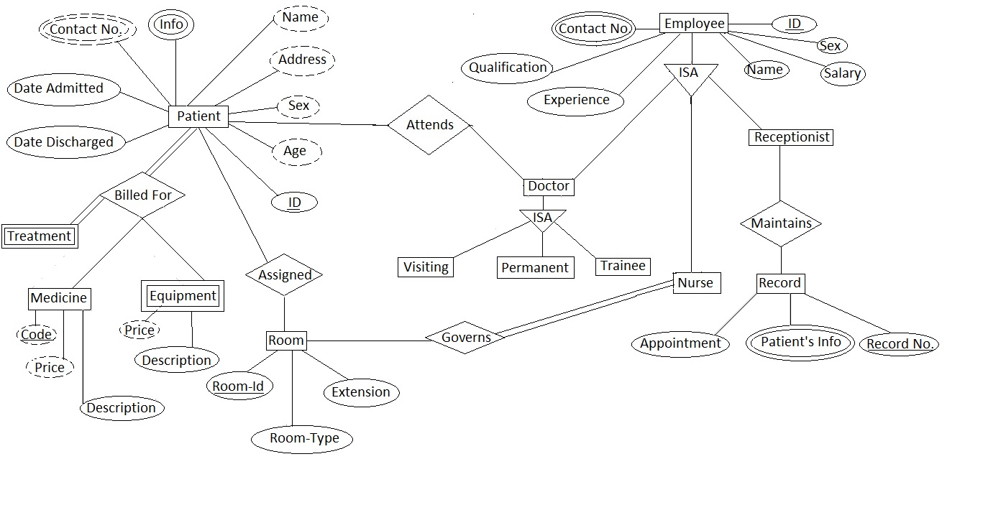

**ASSIGNMENT 1.4:** USE CASE MODEL

The actors of the system are:1. patient,

2.lab-assistant,

3. receptionist,

4. doctors

A Use case diagram is the simplest representation of a system that shows the user’s interaction with the system and shows the relationship between the user and the different use cases in which the user is involved.

Below is the Use case diagram for Hospital Management system -

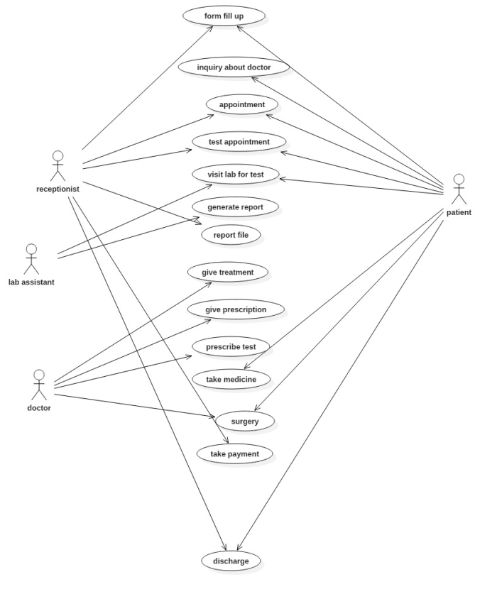 USE CASE DIAGRAM

**ASSIGNMENT 1.5**:CLASS DIAGRAM: A class diagram describes the structure of a system by showing the system’s classes and their attributes.

